**OBJECTIVE**

Our goal is to revolutionize women's safety with a state-of-the-art IoT-based safety watch designed to provide comprehensive protection and peace of mind. Through meticulous research and integration of cutting-edge sensors including GPS, accelerometers, and panic buttons, we aim to create a wearable device that serves as a reliable guardian in all situations. With a focus on real-time monitoring and quick response, our objective is to implement a GPS tracking system that offers precise location information, enabling swift assistance during emergencies. Additionally, we prioritize simplicity and effectiveness in design, ensuring that our user-friendly panic button feature empowers users to trigger emergency alerts with ease. Central to our mission is the development of a robust emergency alert system, capable of promptly notifying predefined contacts or authorities when a safety concern is detected. Furthermore, we aim to enhance user safety and support through the creation of a companion mobile application, equipped with features such as live location tracking, history tracking, and two-way communication. By addressing the multifaceted aspects of women's safety, our objective is to provide a holistic solution that promotes empowerment, security, and confidence in every woman's daily life.

**INTRODUCTION**

In recent years, the issue of women's safety has gained significant attention worldwide, highlighting the urgent need for innovative solutions to address the persistent challenges faced by women in various environments. Women encounter a range of safety concerns, from harassment and assault to abduction and violence, which can impact their freedom, well-being, and sense of security. Recognizing the critical importance of ensuring the safety and empowerment of women, technological advancements have emerged as a promising avenue for intervention.

Introducing an IoT-based Women's Safety Watch, our initiative seeks to leverage the power of technology to redefine safety monitoring and response mechanisms for women. Through a comprehensive approach, we aim to equip women with a wearable device that serves as a reliable companion, offering real-time protection and assistance in times of need. By integrating advanced sensors such as GPS, accelerometers, and panic buttons, our safety watch provides a holistic solution that addresses the multifaceted aspects of women's safety.

**BLOCK DIAGRAM**

Push Button GPS Neo 6m

Arduino Nano

Power Supply GSM 800l

**CIRCUIT DIAGRAM**

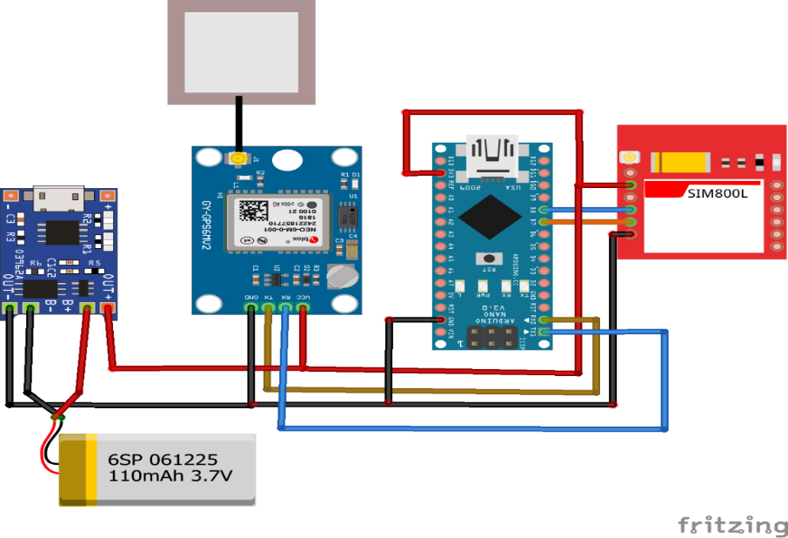

**COMPONENTS USED**

* Arduino Nano
* GPS Neo 6m
* GSM 800l
* Push Button
* Jumper Wires
* Breadboard
* Lithium Polymer Battery

**HARDWARE COMPONENTS DESCRIPTION**

**Arduino Nano**

The Arduino Nano is a compact and versatile microcontroller board based on the ATmega328P chip, offering a wide range of functionalities in a small form factor. Despite its diminutive size, the Nano boasts impressive capabilities, making it a popular choice for various projects, especially those with space constraints. With its onboard USB interface and integrated voltage regulator, the Nano simplifies the process of programming and power supply, making it accessible even to beginners. Its abundance of digital and analog pins allows for seamless connectivity with sensors, actuators, and other peripheral devices, enabling users to create diverse and intricate electronic systems. Whether used for prototyping, education, or embedded applications, the Arduino Nano continues to be a go-to platform for developers and hobbyists alike, thanks to its affordability, versatility, and ease of use.

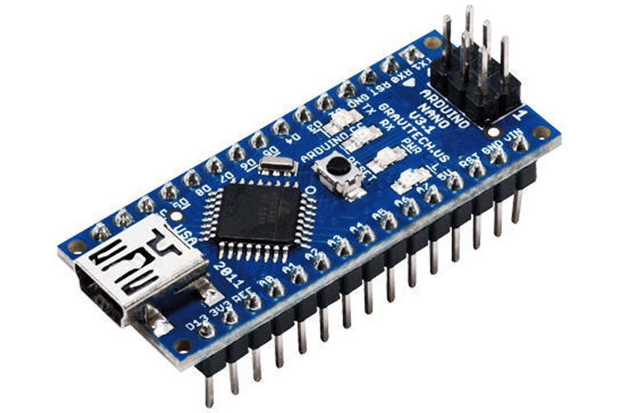

**GPS Neo 6m**

The GPS Neo-6M module represents a pivotal advancement in global positioning technology, offering unparalleled accuracy and reliability in location tracking applications. With its compact form factor and low power consumption, the Neo-6M module is ideally suited for integration into a wide range of devices, including navigation systems, drones, and wearable safety devices. Leveraging cutting-edge satellite positioning technology, the Neo-6M module provides precise real-time location information, enabling users to pinpoint their exact coordinates with exceptional precision. Equipped with multiple satellite constellation support, including GPS, GLONASS, and Galileo, the module ensures robust performance even in challenging environments with limited satellite visibility. Moreover, its fast time-to-first-fix and high update rate capabilities enhance responsiveness, facilitating seamless navigation and tracking experiences. Whether deployed in urban environments or remote wildernesses, the GPS Neo-6M module stands as a testament to innovation in location-based technologies, empowering users with accurate positioning data for a myriad of applications.

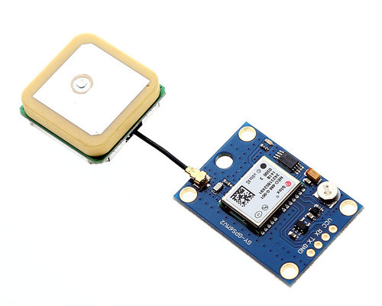

**GSM 800l**

The GSM 800L module is a compact and versatile device that plays a crucial role in enabling communication over GSM (Global System for Mobile Communications) networks. With its small form factor and low power consumption, the GSM 800L module is ideal for embedded systems and IoT applications where space and energy efficiency are paramount. This module supports voice calls, SMS messaging, and GPRS data transmission, making it suitable for a wide range of communication tasks. Its compatibility with standard AT commands simplifies integration into existing systems, while its robust performance ensures reliable connectivity even in challenging environments. Whether used for remote monitoring, asset tracking, or security applications, the GSM 800L module provides a cost-effective solution for establishing wireless communication capabilities in diverse scenarios.

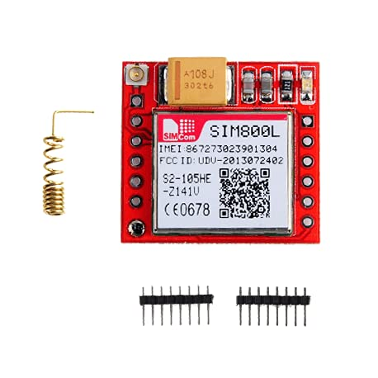

**Push Button**

Push-button technology simplifies tasks by reducing complex operations into a single action. With a mere press, it triggers a sequence of events, from igniting engines to activating machinery or even brewing a cup of coffee. These ubiquitous buttons serve as gateways to convenience, embodying the fusion of human intent with automated functionality. Whether summoning elevators or starting a car, the push button epitomizes the modern ethos of efficiency and accessibility, empowering users with the ability to accomplish tasks effortlessly with just a gentle touch.

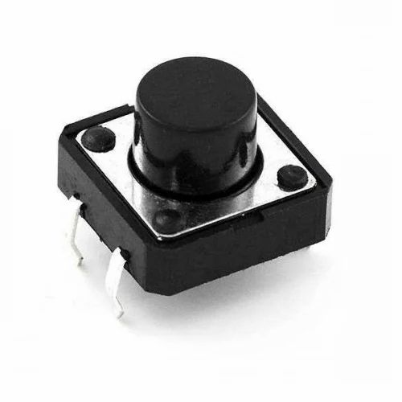

**Jumper Wires**

Jumper wires are essential components in electronics and prototyping, serving as the conduits that connect various elements within circuits. Typically consisting of insulated wires with connectors at each end, jumper wires facilitate the transfer of signals, power, and data between different components like microcontrollers, sensors, LEDs, and more. Their flexibility and ease of use make them invaluable in breadboarding and experimentation, allowing for quick iterations and modifications during the design and testing phases of electronic projects. Jumper wires come in various lengths, colors, and connector types, catering to different needs and preferences. Whether bridging connections on a breadboard or linking components on a PCB, these versatile wires play a crucial role in the world of electronics, enabling innovation and creativity to flourish.

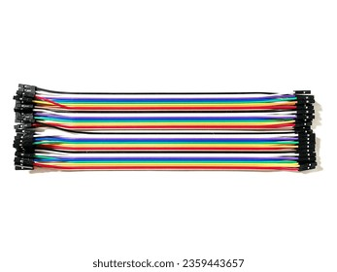

**Breadboard**

A breadboard is a fundamental tool in electronics prototyping, providing a platform for building and testing circuits without the need for soldering. Consisting of a plastic base with numerous interconnected metal clips, a breadboard allows electronic components to be inserted and connected easily. Its grid-like layout, typically divided into rows and columns, provides a convenient structure for organizing and arranging components. Breadboards are often used in conjunction with jumper wires to create temporary connections between components, enabling rapid experimentation and iteration during the design process. With their reusable and versatile nature, breadboards are indispensable for both beginners learning electronics and seasoned engineers prototyping new circuit designs. They offer a practical and user-friendly way to explore circuit concepts, troubleshoot designs, and bring ideas to life without the permanence of soldered connections.

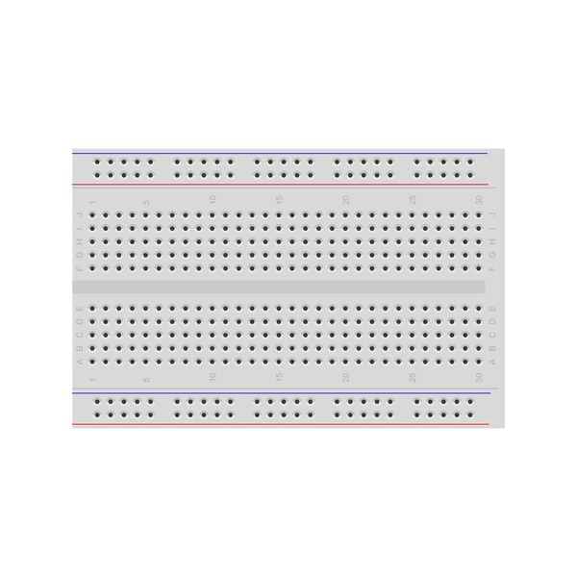

**Lithium Polymer Battery**

A lithium polymer (LiPo) battery with a voltage rating of 3.7 volts is a rechargeable power source commonly used in various electronic devices, such as smartphones, tablets, drones, and portable electronics. LiPo batteries are known for their high energy density, lightweight design, and ability to deliver consistent power output over multiple charge cycles. The 3.7-volt rating represents the nominal voltage of the battery, which is the average voltage it maintains during most of its discharge cycle. However, it's essential to note that the voltage can vary slightly depending on factors like charge level and load. LiPo batteries require special care during charging and usage to prevent overcharging, over-discharging, and physical damage, as mishandling can lead to safety hazards such as swelling, leakage, or even fire. Overall, these batteries are popular choices for applications where compact size, high energy density, and rechargeability are critical considerations.

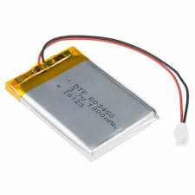

**PROJECT WORKING**

1. Power On

When the Arduino Nano is powered on, it initializes the GSM 800L module and attempts to establish a connection with the local mobile operator.

2. GSM Connection

The GSM module searches for available networks and registers with the strongest one it finds.

Once connected, the GSM module is ready to send and receive SMS messages.

3. GPS Initialization

Concurrently, the GPS NEO-6M module is initialized, and it starts acquiring satellite signals to determine the current location.

4. GPS Location Retrieval

The Arduino continuously reads data from the GPS module to obtain latitude and longitude coordinates representing the current location.

5. Monitoring for Button Press

The Arduino monitors the state of the push button connected to one of its digital pins.

If the push button is pressed, it triggers an interrupt or is checked during the loop iteration, depending on the programming approach.

6. Sending SMS Alert

Upon detecting the button press, the Arduino retrieves the latest GPS coordinates obtained from the GPS module.

It then sends an SMS message to the designated mobile number pre-configured in the program.

The SMS message includes a predefined emergency alert along with the current GPS coordinates of the device.

7. Idle State

The device returns to its idle state, continuously monitoring the GPS location and waiting for any further button presses.

This sequence of operations ensures that the women's safety watch is always ready to provide assistance in case of an emergency. It leverages both the GSM and GPS modules to establish communication and provide accurate location information, while the push button feature enables quick and discreet activation of the emergency alert system.

**APPLICATIONS**

A "women safety watch" incorporating nano, GSM 800L, and GPS Neo 6M modules could serve several crucial purposes:

Location Tracking and Monitoring

The GPS Neo 6M module continuously tracks the wearer's location in real-time.

Family members or friends can remotely access the wearer's location via SMS or a dedicated app for peace of mind.

In case of suspicious or unexpected movements, the watch can automatically send alerts to designated contacts.

Emergency Alert System

In dangerous situations, such as assault or harassment, the wearer can trigger an emergency alert using the watch. The GSM 800L module facilitates sending distress signals or SOS messages to pre-defined contacts or emergency services. These messages could include the wearer's location for swift assistance.

Geo-Fencing and Safe Zones

Users can define safe zones, such as home or work locations, using the watch's interface.

If the wearer enters or leaves a safe zone, the watch sends notifications to specified contacts.

This feature ensures that loved ones are informed of the wearer's movements and can take action if necessary.

Route Assistance and Navigation

The GPS module provides turn-by-turn navigation instructions to guide the wearer to their destination.

If the wearer deviates from the intended route or encounters obstacles, the watch can suggest alternative paths or send alerts to check on their safety.

Voice Communication Capability

The GSM module allows for two-way voice communication in addition to SMS alerts.

This feature enables the wearer to directly communicate with emergency services or trusted contacts in urgent situations.

Battery Efficiency

Since safety is paramount, ensuring the watch remains powered is essential. Efficient power management algorithms can be implemented to optimize battery usage, ensuring the device remains operational for extended periods.

Panic Button Integration

Enable the watch to connect with nearby panic buttons or emergency assistance systems. In case of danger, the wearer can activate these external resources for immediate help and support.

By integrating these modules and functionalities, the women safety watch can provide a comprehensive solution for enhancing the safety and security of its users, empowering them to navigate the world with confidence and peace of mind.

**CONCLUSION**

The integration of Arduino Nano, GPS NEO-6M, and GSM 800L modules in a women's safety watch presents a powerful tool to address safety concerns effectively. By leveraging these technologies, the watch offers real-time location tracking, emergency alerts, and additional safety features crucial for ensuring the well-being of women in various situations. This innovative solution not only provides peace of mind to wearers and their loved ones but also empowers women to navigate their surroundings with confidence.

Through its compact design and user-friendly interface, the watch becomes an essential accessory for enhancing personal safety. Furthermore, the versatility of Arduino Nano allows for customization and expansion of functionalities, enabling continuous improvement and adaptation to evolving safety needs. Whether it's triggering distress signals, establishing safe zones, or recording evidence, the watch serves as a proactive measure against potential threats. In essence, the women's safety watch utilizing Arduino Nano, GPS NEO-6M, and GSM 800L modules represents a significant step towards creating safer environments and fostering a culture of empowerment and security for women everywhere.